MCI - Lab 02
Muhammad Mughees Siddiqui 10047
Hamza Sami 09934
Task 0:
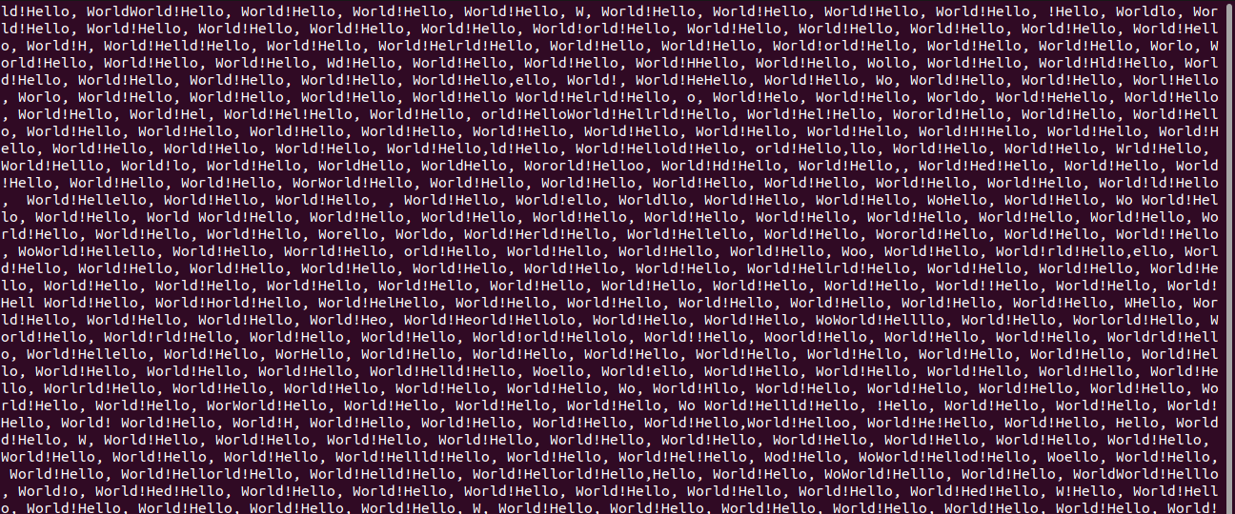
Task 1:
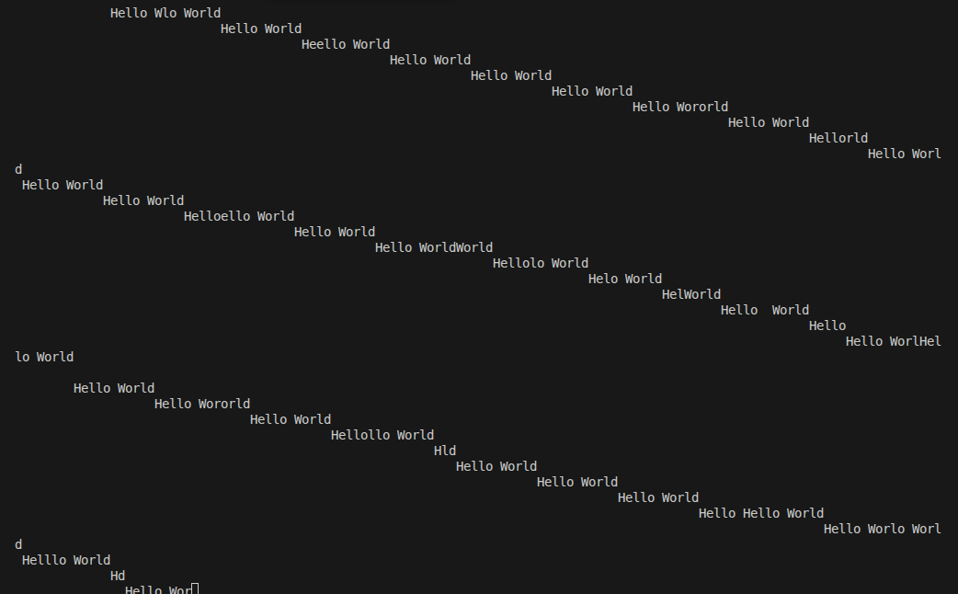

Task 2:
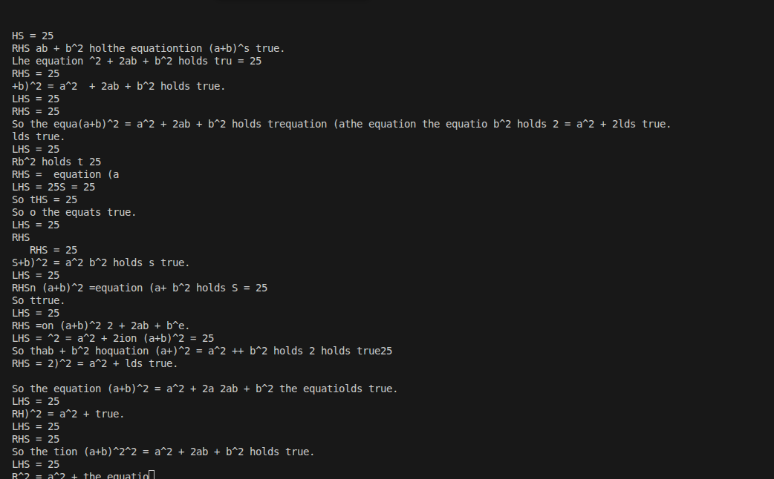
Task 3:

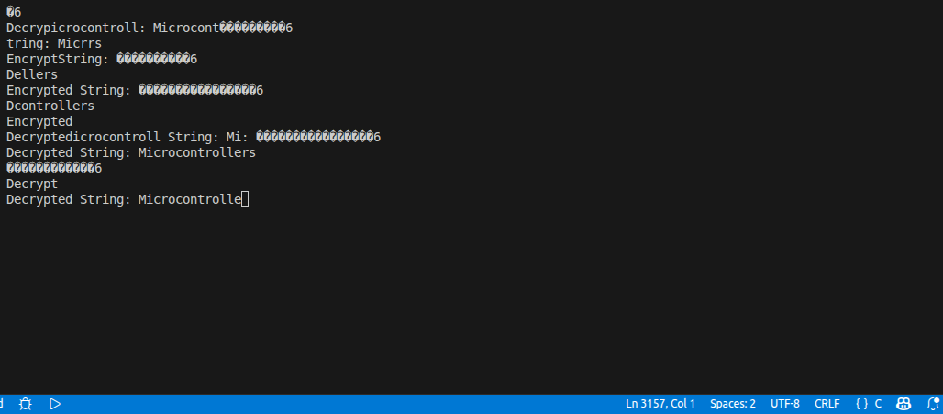

Task 4:

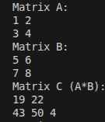

Task 5:
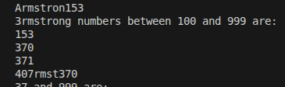

Evaluation Questions:

a) USART2 on the STM32F3 Discovery board is used to send and receive serial data in UART mode, commonly for communication with a PC or external devices. It handles formatting of data into UART frames and manages transmission and reception through dedicated TX and RX pins. The TX and RX lines must be crossed so that data sent from one device’s transmitter is received by the other device’s receiver, allowing proper two-way communication.

Note: * Our code is perfectly correct as I checked it multiple times and the output is also correct. However, The problem is with scrambled output we are getting. That is most likely due to buad rate and we will also inquire from the instructor regarding this. It’s my request to please consider it while marking the lab*.

